Lab Assignment 2.1

Task 1: Statistical Summary for Survey Data

Scenario:
- You are a data analyst intern working with survey responses stored as numerical lists.

Task:
- Use Google Gemini in Colab to generate a Python function that reads a list of numbers and calculates the mean, minimum, and maximum values.

Expected Output:
- Correct Python function
- Output shown in Colab
- Screenshot of Gemini prompt and result

Google Colab Workspace Screenshots:

Generate a Python function that reads a list of numbers and calculates the mean, minimum, and maximum values.

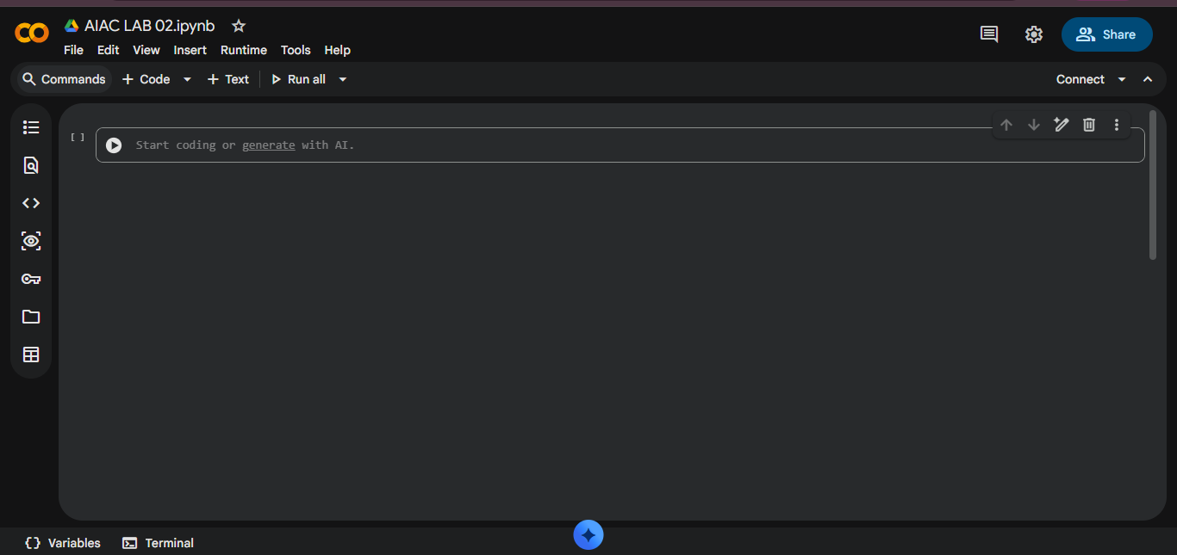
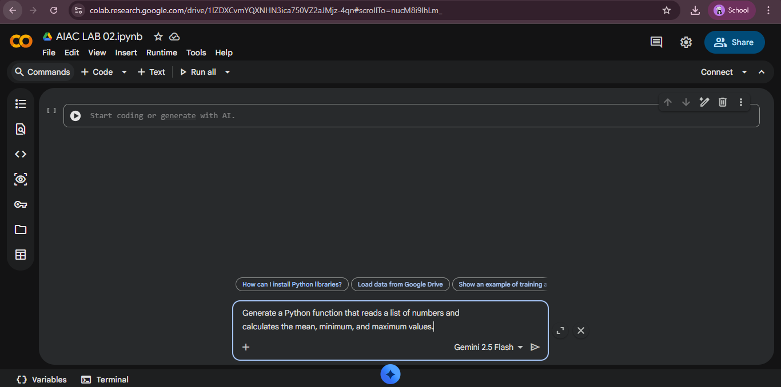

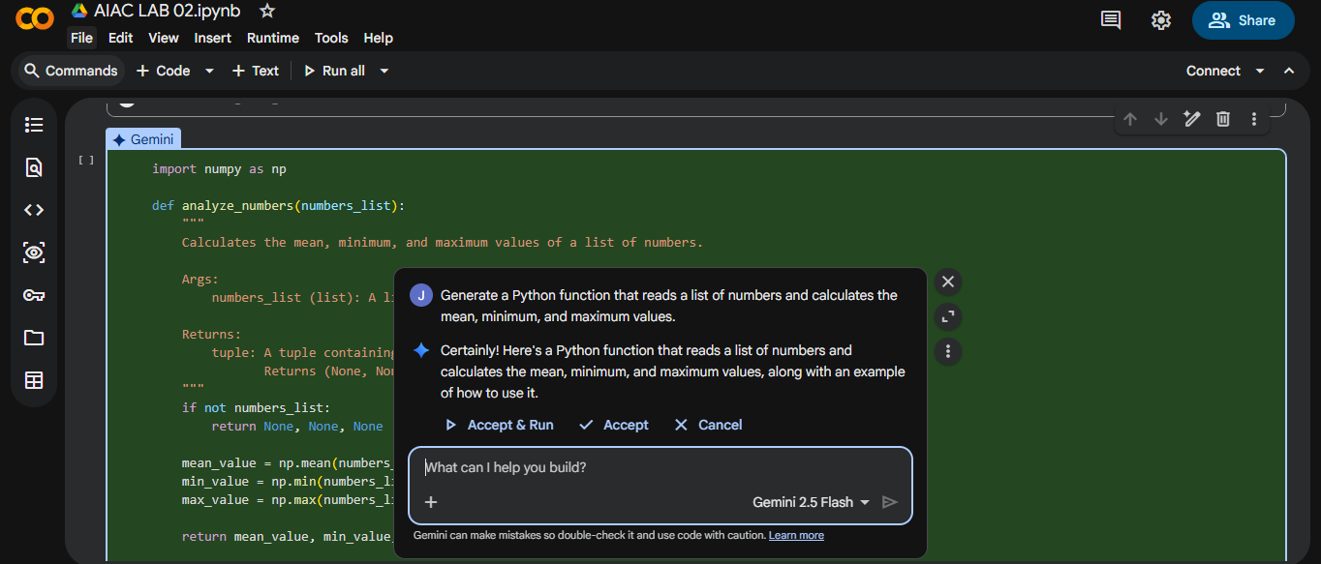
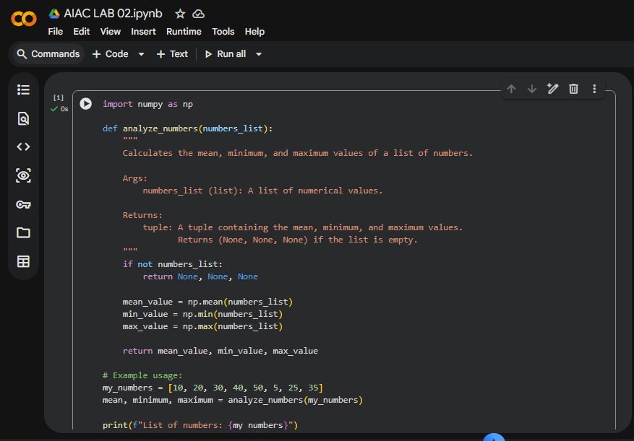

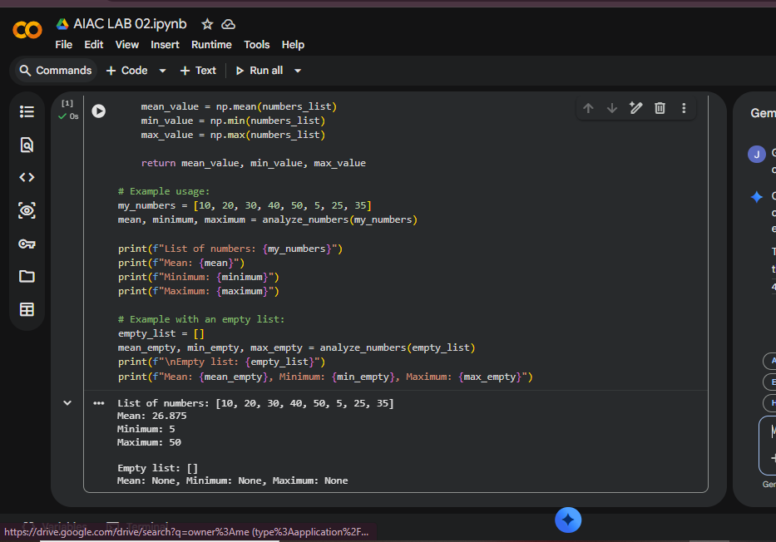

Task 2: Armstrong Number – AI Comparison

Scenario:
- You are evaluating AI tools for numeric validation logic.

Task:
- Generate an Armstrong number checker using Gemini and GitHub Copilot.
- Compare their outputs, logic style, and clarity.

Expected Output:
- Side-by-side comparison table
- Screenshots of prompts and generated code

Google Colab Workspace Screenshots:
Write a Python function to check if a number is an Armstrong number
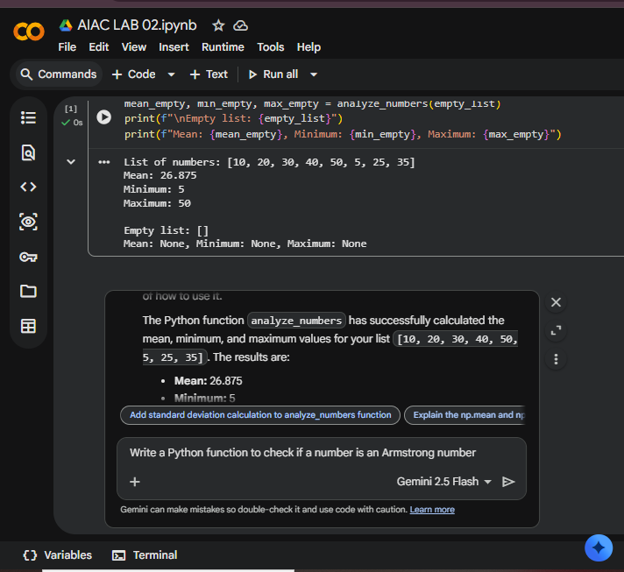

Dfvhbn

Tgrhnmnb

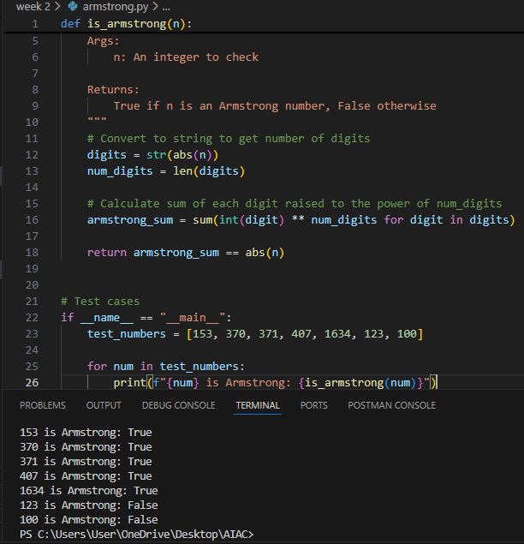

Task 3: Leap Year Validation Using Cursor AI

Scenario:
- You are validating a calendar module for a backend system.

Task:
- Use Cursor AI to generate a Python program that checks whether a given year is a leap year.
- Use at least two different prompts and observe changes in code.

Expected Output:
- Two versions of code
- Sample inputs/outputs
- Brief comparison

Version - 1: Instruction Given:
Write a Python function to check if a year is a leap year and include test cases.
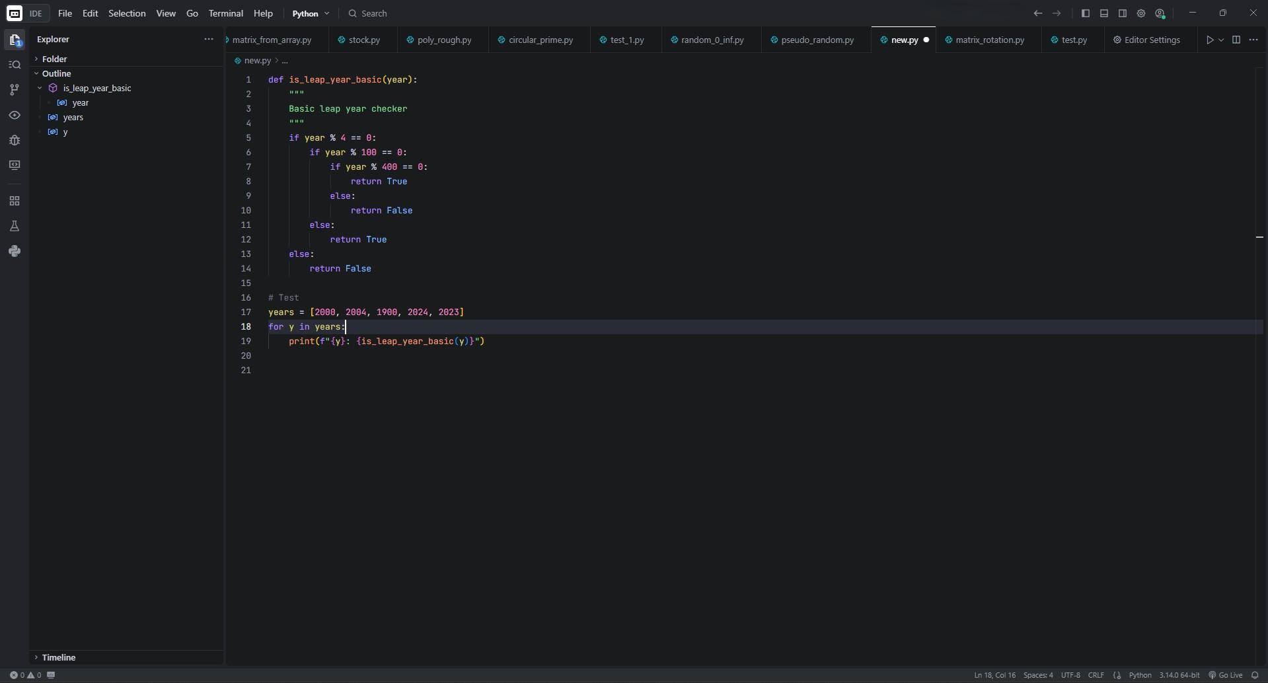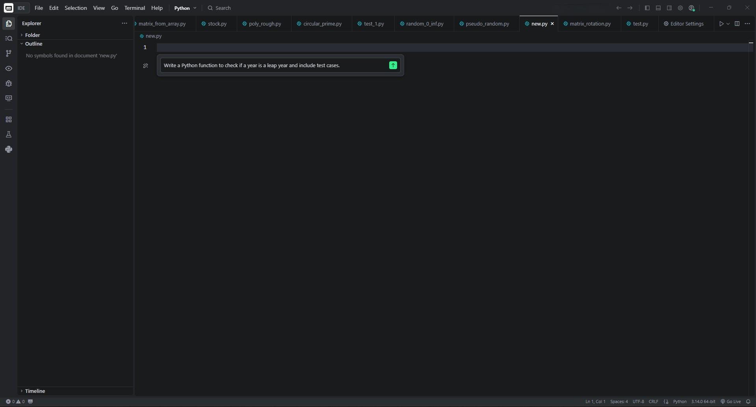

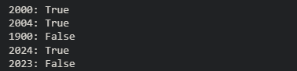
Code Output:
Version - 2: Instruction Given:
Create a more concise Python leap year checker with better readability and comprehensive testing.
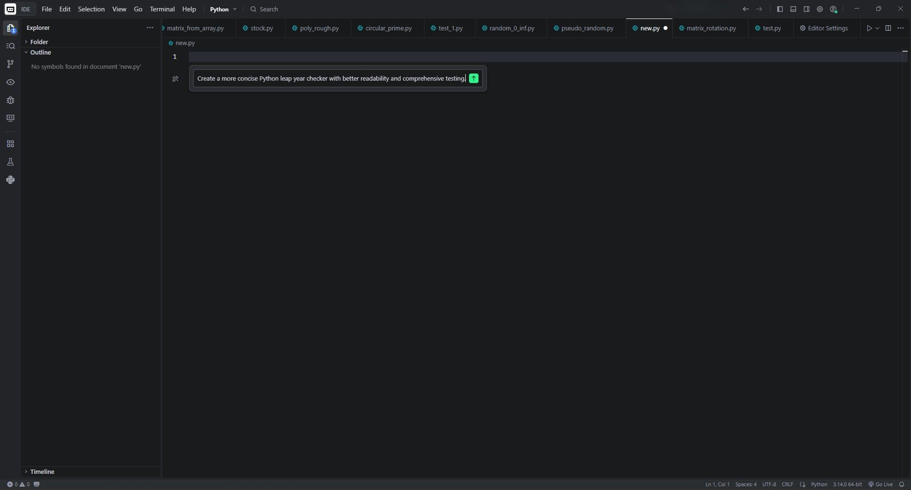
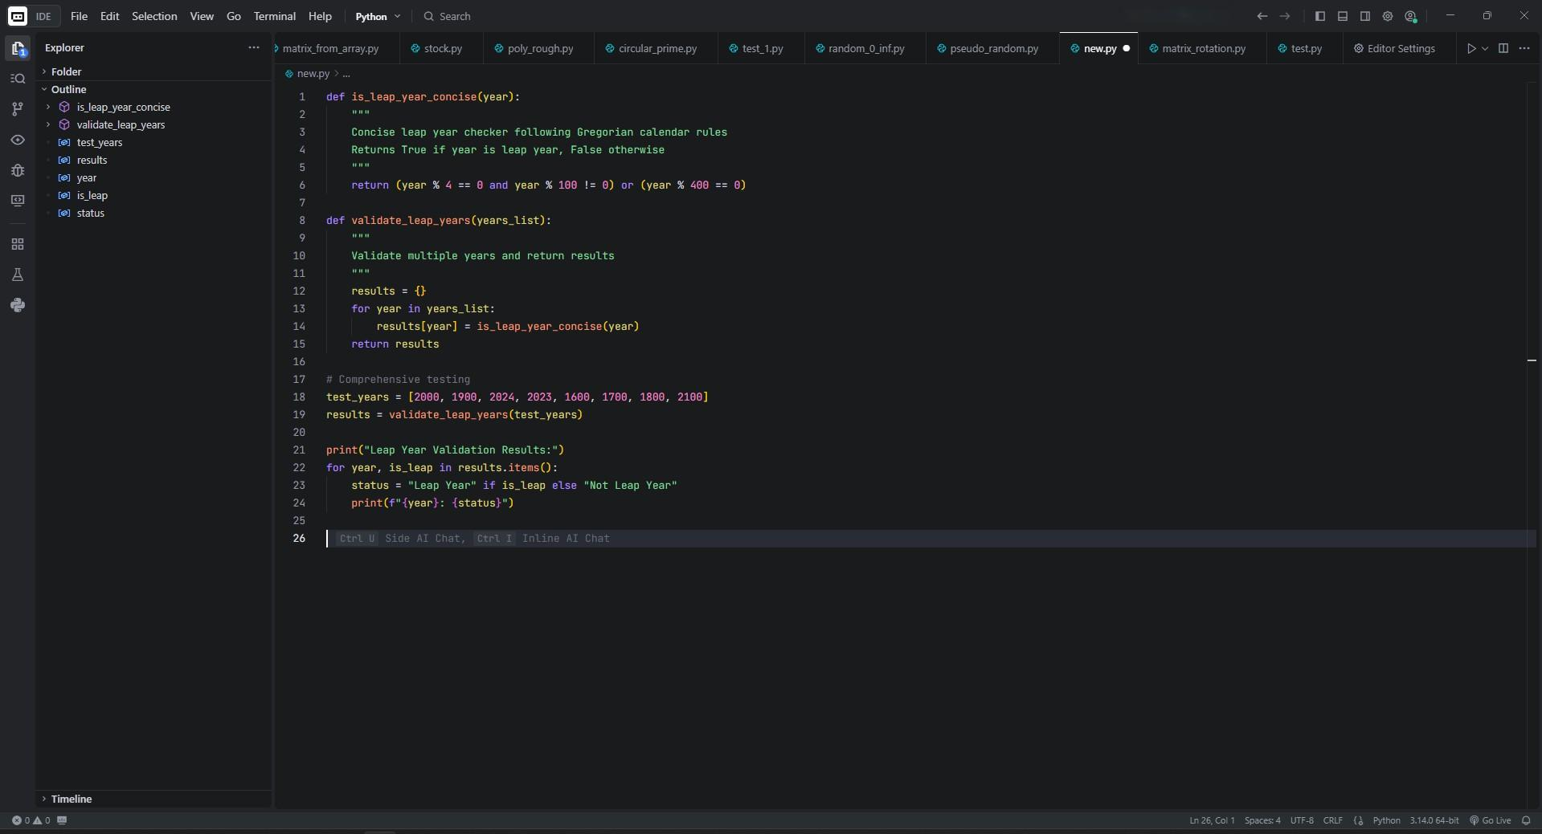

Code Output:
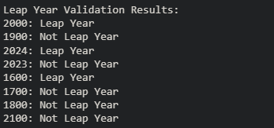

Brief comparison:
Version 1 (Basic) | Version 2 (Concise)
Uses nested if-else statements | Single return statement with logical operators

More lines of code (12 lines) | Fewer lines (5 lines for main function)
Easier for beginners to understand | Follows Python style guide
Step-by-step logic | Combined logical conditions
Includes basic testing | Includes comprehensive testing function

Task 4: Student Logic + AI Refactoring (Odd/Even Sum)

Scenario:
- Company policy requires developers to write logic before using AI.

Task:
- Write a Python program that calculates the sum of odd and even numbers in a tuple, then refactor it using any AI tool.

Expected Output:
- Original code
- Refactored code
- Explanation of improvements

Original Code written by me:
def even_odd_sum_tuple(num): even_sum = 0
odd_sum = 0

for i in range(1, num+1): if i%2 == 0:
even_sum += i else:
odd_sum += i

return even_sum, odd_sum

user_input = int(input("Enter a number: "))

even, odd = even_odd_sum_tuple(user_input) print(f"Sum of even numbers: {even}") print(f"Sum of odd numbers: {odd}")
Refactored code:
Instructions given:
Refactor the code in order to make it handle input validation, readability and handle edge cases.
def even_odd_sum_tuple(n: int) -> tuple[int, int]: """
Calculate the sum of even and odd numbers from 1 to n.

Parameters:
n (int): The upper limit (must be a positive integer).

Returns:
tuple[int, int]: (sum_of_even_numbers, sum_of_odd_numbers)
"""
if n < 1:
return (0, 0) # No positive range to sum even_sum, odd_sum = 0, 0
for i in range(1, n + 1): if i % 2 == 0:
even_sum += i else:
odd_sum += i return even_sum, odd_sum
try:
user_input = int(input("Enter a positive integer: ")) if user_input < 1:
print("Please enter a positive integer greater than 0.") else:
even, odd = even_odd_sum_tuple(user_input) print(f"Sum of even numbers: {even}") print(f"Sum of odd numbers: {odd}")

except ValueError:
print("Invalid input! Please enter a valid integer.")

Explanation of improvements:
Input validation
- Making sure the user enters a valid integer.
- Handling negative numbers gracefully (return (0,0) or raise an error). Readability
- Using clear variable names.
- Adding docstrings and comments. Edge cases
- If input is 0, both sums should be 0.
- If input is negative, we can either reject it or compute sums up to that number (here I’ll reject it for clarity).

